
CO2 - ASSESSMENT 3
 |  | SCENARIO-BASED ASSESSMENT
Course Faculty | : | Dr. K. Anbazhagan
Course Name | : | Ethical Hacking
Course Code | : | ITA1406
Slot | : | Slot B
Total Marks | : | 100

CO2 :
Foot printing Tools: Conducting Competitive Intelligence, DNS Zone Transfers,
Introduction to Social Engineering: Social Engineering Attacks and Countermeasures. (BT3)

Code of Conduct:
I P Sai Rakesh Reddy (192365060) (Name / Reg No) certify that this submission is my original work and that I have adhered to the guidelines specified for this assessment.
I understand that any violation of academic integrity rules will result in disciplinary action.

Signature of the student: Rakesh

Visit https://dnsdumpster.com. Find your assigned website

S.No. | Register Number | Assigned Website
1 | 192110443 | www.zoho.com
2 | 192311036 | www.google.com
3 | 192311153 | www.microsoft.com
4 | 192311364 | www.apple.com
5 | 192311407 | www.amazon.com
6 | 192312440 | www.ibm.com
7 | 192312550 | www.oracle.com
8 | 192321167 | www.intel.com
S.No. | Register Number | Assigned Website
9 | 192324124 | www.cisco.com
10 | 192365060 | www.adobe.com
11 | 192371023 | www.salesforce.com
12 | 192372042 | www.sap.com
13 | 192372149 | www.dell.com
14 | 192372204 | www.hp.com
15 | 192411180 | www.nvidia.com
16 | 192421051 | www.meta.com
17 | 192421094 | www.netDlix.com
18 | 192421098 | www.spotify.com
19 | 192421159 | www.uber.com
20 | 192421285 | www.airbnb.com
21 | 192421438 | www.tcs.com
22 | 192424054 | www.infosys.com
23 | 192424218 | www.wipro.com
24 | 192425179 | www.hcltech.com
25 | 192425307 | www.techmahindra.com
26 | 192472027 | www.ltimindtree.com
27 | 192472250 | www.accenture.com
28 | 192472274 | www.capgemini.com
29 | 192472330 | www.cognizant.com
30 | 192472367 | www.zensar.com
31 | 192521119 | www.paypal.com
32 | 192565066 | www.stripe.com
33 | 1911260079 | www.atlassian.com
34 | 1911260172 | www.dropbox.com
35 | 1921260029 | www.cloudDlare.com
36 | 1921260276 | www.mongodb.com
37 | 1924260170 | www.redhat.com
38 | 1925260075 | www.vmware.com
39 | 1965260048 | www.openai.com
40 | 1965260160 | www.github.com

- under "Enter a Domain to Test" -- Type your domain
- Click Start Test
- Upload complete report as .xlsx Qile which you downloaded after Test
- Upload map generated by DNSDumpster
RUBRICS

Criteria | Weightage (%) | Level 4 (Exemplary) | Level 3 (ProVicient) | Level 2 (Developing) | Level 1 (Beginning)
DNS Footprinting  Execution | 25% | Successfully performs DNS  footprinting on the assigned domain  using DNSDumpster and follows the  complete procedure accurately. | Performs DNS footprinting  correctly with  minor procedural errors. | Performs basic DNS footprinting with assistance. | Unable to perform the  required DNS footprinting.
DNS Information IdentiVication | 25% | Accurately identiQies and interprets  relevant DNS, host,  IP, and infrastructure  information from the generated results. | IdentiQies most relevant  information with minor omissions. | IdentiQies some DNS information but  provides limited interpretation. | Fails to identify or interpret  relevant DNS information.
Analysis of DNS  Infrastructure | 30% | Thoroughly analyzes the DNS  map and discovered infrastructure and  explains its security signiQicance clearly. | Correctly analyzes most  infrastructure  information with minor gaps. | Provides basic analysis but misses important  relationships or security implications. | Unable to analyze the  DNS  infrastructure meaningfully.
Report and  Evidence  Presentation | 20% | Submits a complete Excel report and  DNS map with clear, accurate, and wellorganized evidence. | Provides the required report  and map with minor  documentation issues. | Submission is partially complete or poorly organized. | Required report/map is missing,  incomplete, or unusable.

Report screenshots:

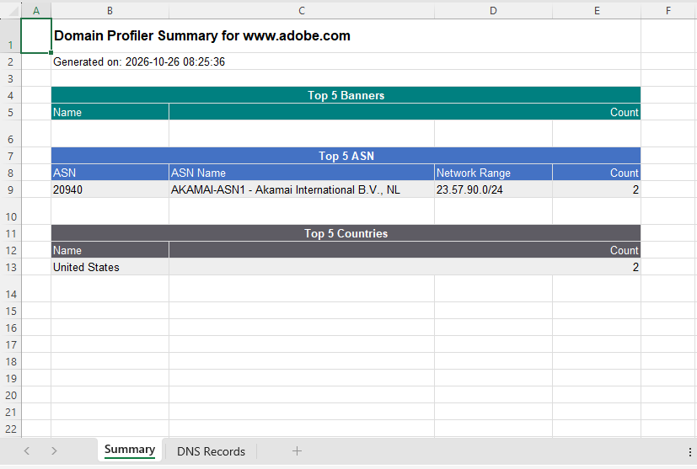

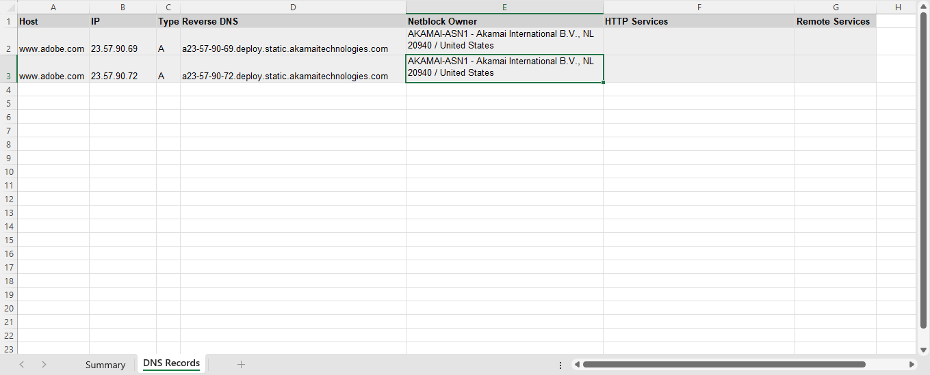

Map generated by DNSDumpster:

